Linux Servers
Lab1 – Infrastructure Server
Joni Korpihalkola
Document your commands or take screenshots. Answer questions in english or finnish.
All configuration must be persistent (survive a reboot). You may use your own notes and Internet resources for your aid. You may consult the teacher or other students.
The labs use the following topology:

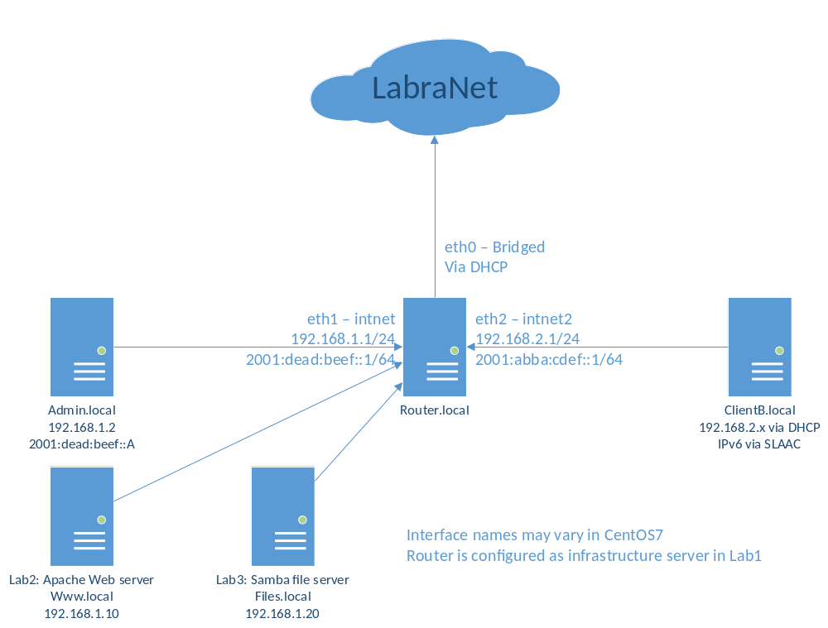

Generic routing and firewalling (1p)
Configure IP and IPv6 forwarding in Router.local. (/etc/sysctl.conf)
Muokkasin /etc/sysctl.conf tiedostoon ipv6 forwardingin päälle
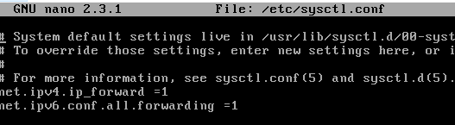
Ja /etc/sysconfig/network tiedostoon kirjoitin rivin:
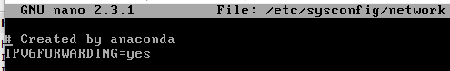
Käynnistin palvelun uudestaan ja testasin että ipv6 forwarding on päällä:
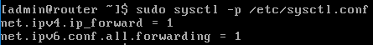
Configure firewall (either FirewallD or iptables): Both internal networks must be allowed access to internet. NAT (masquerade) must be used on the outgoing interface. intnet network is considered as trusted and may access intnet2 but not the other way around.
Routerilla firewall sääntö, että pääsee nettiin, joka tehty komennolla firewall-cmd –direct –add-rule ipv4 nat POSTROUTING 0 –o enp0s3 –j MASQUERADE:
Määrätään intnet1 trusted zone:ksi /etc/sysconfig/network-scripts kansiosta:
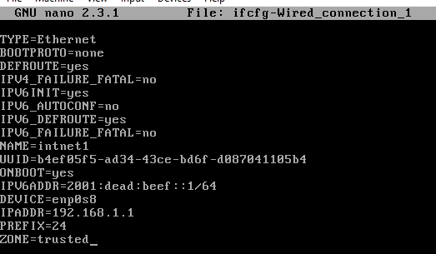
Määritetään intnet2 internal zoneksi samasta kansiosta: 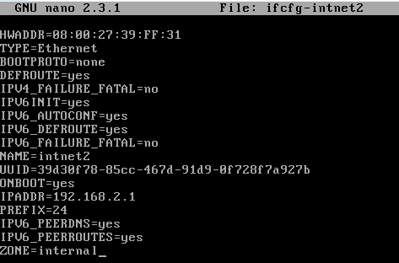
The following services/ports need to be allowed in internal zone: dns/udp53, ping/icmp
Lisäsin firewall sääntöihin ensin dns palvelun:
Tälle avasin portin 53 udp:
ICMP-block ei ollut oletuksena päällä internal zonessa, joten ping toimii:
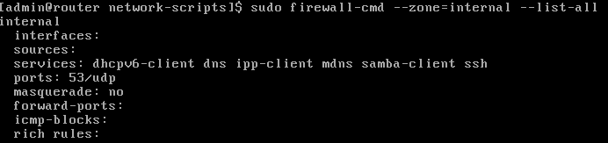

Zones to be used if configuring with firewallD: external, trusted, internal. (Use network-scripts to configure zones, ZONE=xxx). DO NOT use firewall-cmd --change-zone or --change-interface, it will NOT work.

Name resolution (1p)
Install BIND on Router.local as a resolving name server. Listen at all interfaces but allow queries from internal networks only.
Asennetaan BIND:
Muokataan BINDin conffia /etc/named.conf ja laitetaan se kuuntelemaan kaikkia rajapintoja ja sallitaan kyselyt vain internal networkista:
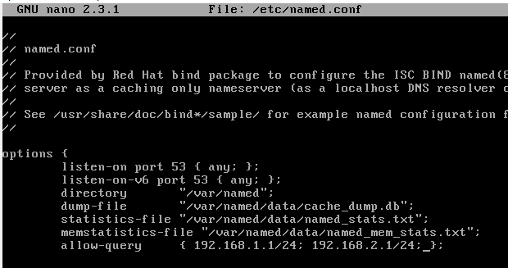

Local names (1p)
Create a .local –zone and corresponding reverse zone in BIND (example zones can be found in Optima ) and add the following name-IP mappings in them:
- router.local – 192.168.1.1
- admin.local – 192.168.1.2
- www.local – 192.168.1.10
- files.local – 192.168.1.20
En saanut toimimaan

DHCP (1p)
Install isc-dhcp –server (or dhcp3) and set it to serve addresses to 192.168.2.0/24 with it. Serve 192.168.2.1 as the gateway and also as the DNS server in the network. See /usr/share/doc/dhcp-4.2.5 for config examples.
Dhcp:n asennus:
Kopioin esimerkin /usr/share/doc/dhcp-4.2.5 kansiosta /etc/dhcp/dhcpd.conffiin, kommentoin muut kohdat ja lisäsin jakamaan osoitteita välillä 192.168.2.0 – 192.168.2.254, default gatewayksi 192.168.2.1 ja nimipalvelimeksi 192.168.2.1:

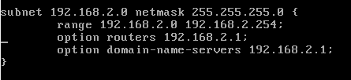

IPv6 & SLAAC (1p)
Set the IPv6 addressing as shown in the topology. Install radvd-package and set it to serve IPv6 addresses from 2001:abba:cdef::/64 network to intnet2. Default settings in /etc/radvd.conf will be mostly correct.
Radvd asennus:
Muokkasin radvd.conf tiedostoon interfacen enp0s9, joka on intnet2 ja laitoin ipv6 osoitteen prefix:ksi 2001:abba…jne
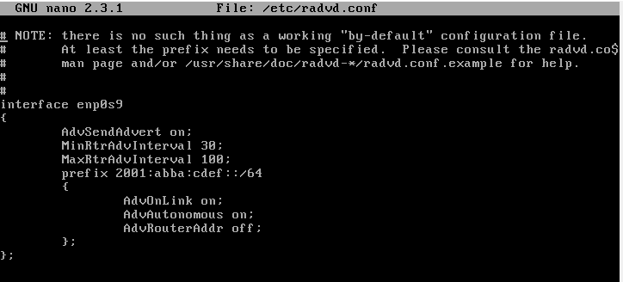

Testing
Reboot router.local and admin/client and verify that your configuration persists. Test that you can access Internet from Admin.local and ClientB.local. Test that you can ping and ping6 ClientB from Admin.local.
Checklist for screenshots/documentation:
- Services are running after a reboot (systemctl status service) and firewall-rules are in effect (firewall-cmd --list-all or iptables -nvL)
Rebootin jälkeen:
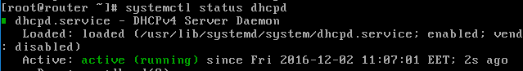
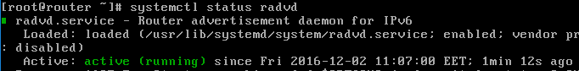
- ClientB gets both IPv4 and IPv6 address, gateway and a DNS server (ifconfig, /etc/resolv.conf, route -n, route -6 -n)
ClientB saa IPv4 ja IPv6 osoitteet:
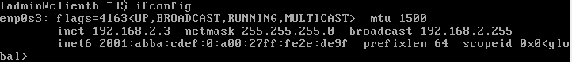
Route –n tuloste:
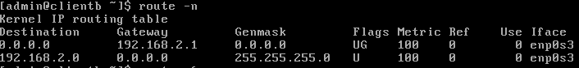
Route -6 –n tuloste:
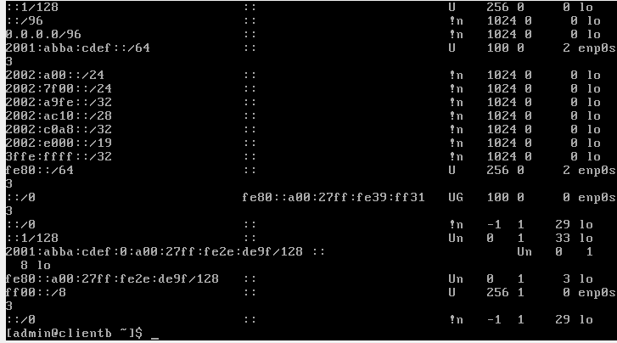

- ClientB can resolve www.google.com and router.local or any other names (dig/nsloookup)
Ei pysty
- Admin can ping and ping6 ClientB, ClientB can ping gateway and www.google.com, Admin can ping www.google.com
Adminin ping clientB:lle:
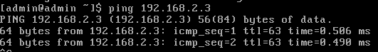
- wget www.google.com loads index.html
